Zomato (Integration) :

Integrate Zomato with Petpooja :
Important Note (Zomato):
To disconnect the Zomato or Cloud Kitchen integration, send an email to support@petpooja.com from your registered email ID, clearly mentioning the reason for the disintegration.
Important Note (Zomato) :
To increase the preparation time in Zomato, you need to contact the Zomato Support Team.
Important Note (Zomato):
Open items with a price of ₹0 are not considered by Zomato. Please ensure that all open items have a valid price for successful menu sync.
Path : billing.petpooja.com >> Explore products >> integration >> Zomato .

outletwise_link : https://billing.petpooja.com/market/zomato_details/
Steps to reach Zomato:
Step 1 : Billing.petpooja.com in Steps to reach Zomato : Open your browser and go to billing.petpooja.com.
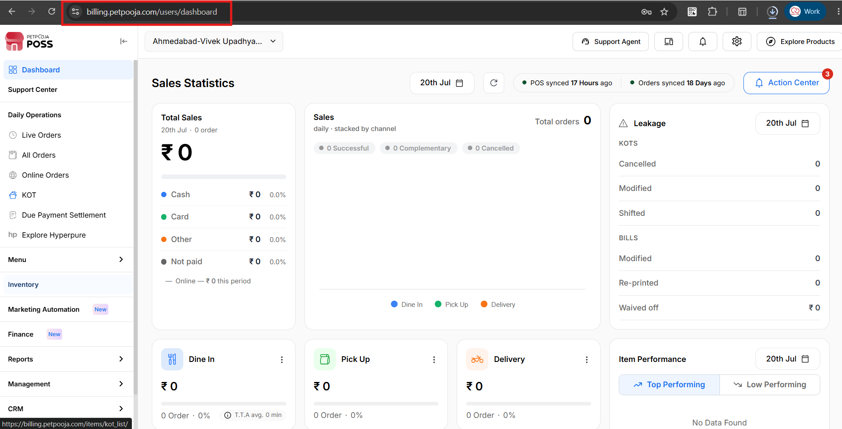
{Image Name: PetPooja Dashboard,
Description: The highlighted URL indicates that this is the billing.petpooja.com.Here is an image of step 1 Billing.petpooja.com in Steps to reach Zomato}
Step 2 : Marketplace in Steps to reach Zomato : Click on the Marketplace section from the dashboard.
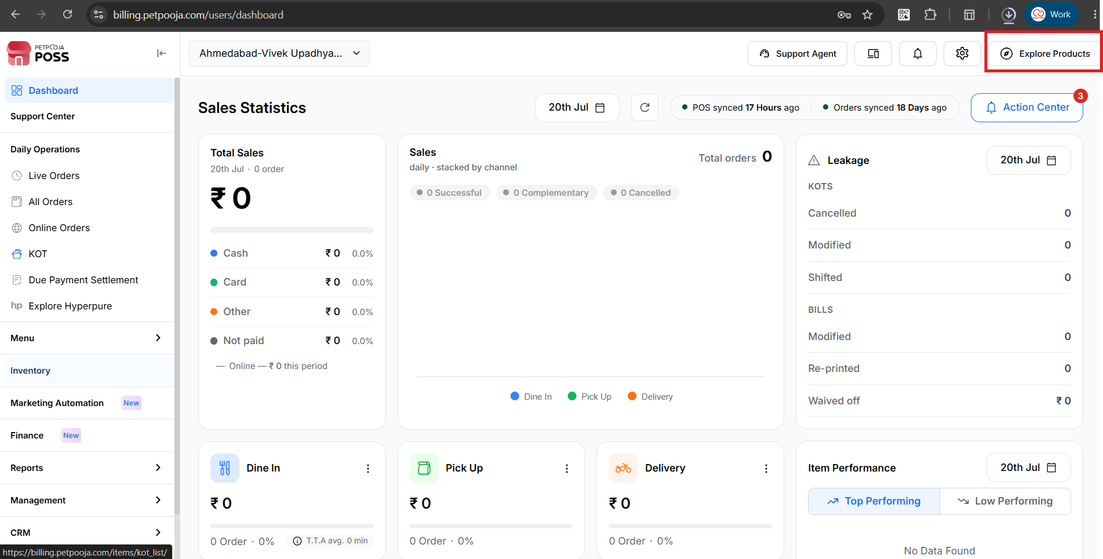
{Image Name: PetPooja Marketplace,
Description :Here is an image shows of In the top right corner, the "Marketplace" button is prominently highlighted in red.Here is an image of step 2 Marketplace in Steps to reach Zomato}
Step 3 : Integration in Steps to reach Zomato : Inside the Marketplace section, click on Integration.
Step 4 : Zomato in Steps to reach Zomato : Inside Integration, click on Zomato.
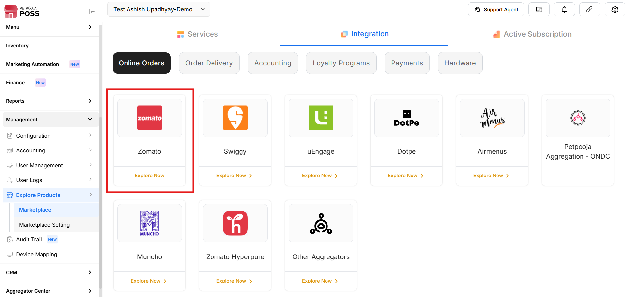
{Image Name : Petpooja Zomato,
Description : Here is an image showing Zomato highlighted in the Red Box.Here is an image of step 3 Integration and step 4 Zomato in Steps to reach Zomato}
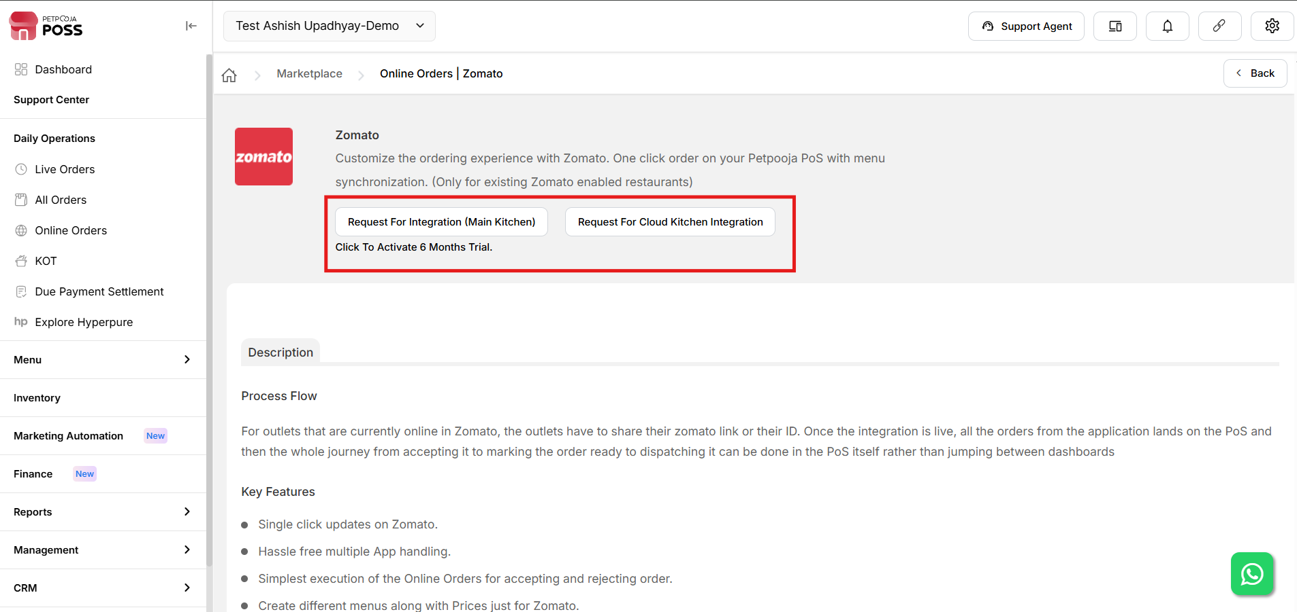
{Image Name: PetPooja Zomato Integration,
Description : This image shows the Zomato integration page within the PetPooja system.}

Which Option Should You Choose?

outletwise_link : https://billing.petpooja.com/market/zomato_details/
- If this is your first integration with Petpooja →Select "Request for Integration (Main Kitchen)"
- If you already have one integration and need a second one →Select "Request for Cloud Kitchen Integration"

Fill the Zomato Integration Form in Petpooja (Zomato):

outletwise_link : https://billing.petpooja.com/market/zomato_details/

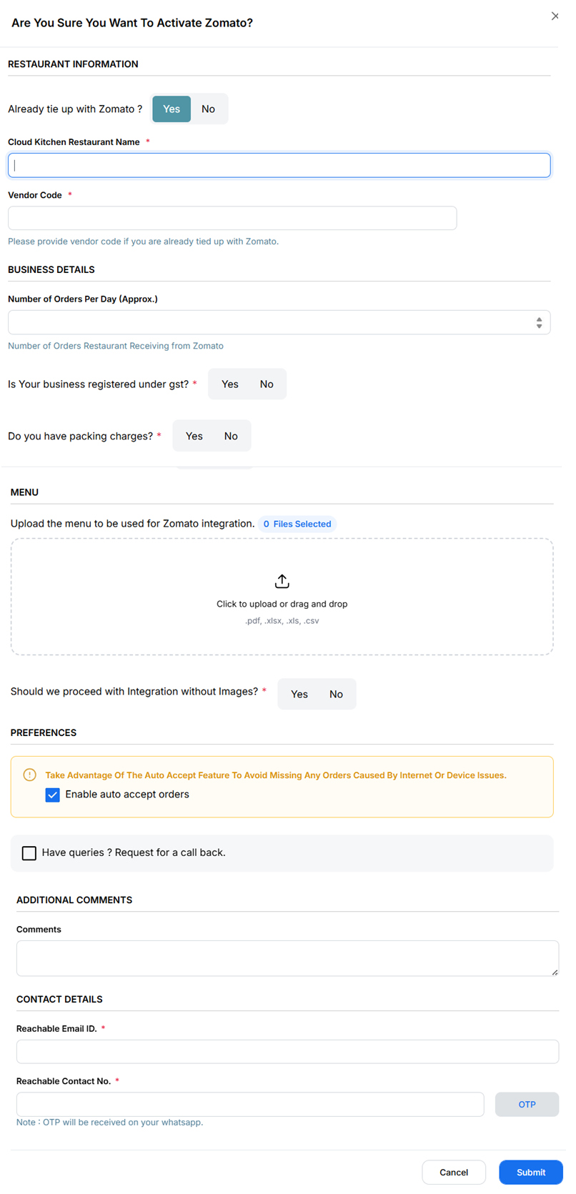

{Image Name: PetPooja Zomato Integration Form,
Description: This image displays the Zomato integration form in the PetPooja dashboard.}

(Zomato) Note: Kindly allow 2 to 3 working days for the integration process to be fully implemented after you have submitted this form.

How to Fill the Zomato Integration Form in Petpooja (Zomato) :
outletwise_link : https://billing.petpooja.com/market/zomato_details/

Step 1: Already Tied Up with Zomato? (Zomato) :
- Select "Yes" if your restaurant is already registered with Zomato.
- Select "No" if you are integrating with Zomato for the first time.

Step 2: Cloud Kitchen Restaurant Name (Zomato) :
- Enter your restaurant name as listed on Zomato.
- Ensure the spelling matches your Zomato profile to avoid sync issues.

Step 3: Vendor Code (Zomato) :
- If you are already tied up with Zomato, provide your Zomato Vendor Code.
  - You can find this code in your Zomato Partner Dashboard or request it from Zomato Support.

Step 4: Number of Orders Per Day (Approx.) (Zomato) :
- Mention an approximate number of daily orders your restaurant receives from Zomato.
  - Example: 50 orders/day, 100 orders/day, etc.
- This helps Petpooja optimize the system for your volume.

Step 5: Do You Charge GST on Your Zomato Menu? (Zomato) :
- Select "Yes" if GST is applicable on your menu prices.
- Select "No" if your prices are tax-inclusive or if GST does not apply.

Step 6: Do You Have Packing Charges Applied on Your Zomato Menu? (Zomato) :
- Select "Yes" if you charge extra for packaging.
- Select "No" if packaging is included in the menu price.

Step 7: Upload Menu for Zomato Integration (Zomato) :
- Click "Choose Files" to upload your menu.
- Ensure the uploaded file includes:
  - Menu items with correct names.
  - Prices as they should appear on Zomato.
  - Taxes and additional charges (if applicable).
- Note: The attached menu will be visible on Zomato after integration.
Step 8 : Should we proceed with Integration without Images ( Zomato ):
- Yes, Proceed with Integration Without Images
  - Continue the integration process without adding images.
- No, Wait for Images Before Integration
  - Hold the integration process until images are available.

Step 9 : Enable Auto Accept Orders (Zomato) :
- Keep this checked to automatically accept orders and avoid missing any due to internet or device issues.
- If unchecked, orders may require manual approval, which could lead to delays.

Step 10: Request a Call Back (Optional)
- If you have any queries or need assistance, tick the checkbox "Have queries? Request for a call back."
- A Petpooja representative will contact you for further support.

Step 11: Comments (Optional) (Zomato) :
- Add any additional details or special requests for the integration.
  - Example: "We operate multiple cloud kitchens" or "Urgent integration needed."

Step 12: Reachable Email ID (Zomato) :
- Provide a working email address for official communication.
- You will receive integration updates and order-related information here.

Step 13: Reachable Contact Number (Zomato) :

- Note : OTP will be received on your whatsapp
- Enter a valid phone number where you or your team can be contacted.

Final Step 13 : Submit the Form (Zomato) :
- Double-check all the details and click Submit to complete your integration request.

Zomato Integration Status Tracking in Petpooja (Zomato) :

outletwise_link : https://billing.petpooja.com/market/zomato_details/
Once you have submitted your integration request, you can track the Zomato integration process in Petpooja. The status will go through multiple steps before becoming fully operational.

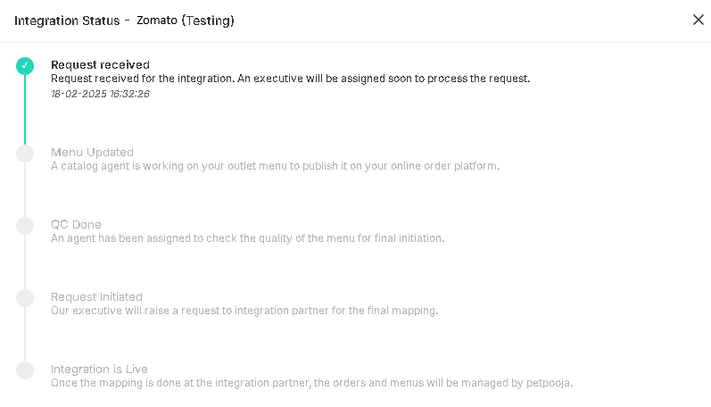
{Image Name: PetPooja Zomato Integration Status,
Description : Here is an image of the Zomato integration Tracking process in Petpooja.}

Integration Status Of Zomato (Zomato):
outletwise_link : https://billing.petpooja.com/market/zomato_details/

Step 1: Request Received (Integration Status Of Zomato) :
Status: Your integration request has been received.
Next Action: A Petpooja executive will be assigned to process your request.

Step 2: Menu Updated (Integration Status Of Zomato) :
Status: A catalog agent is updating your outlet menu.
Next Action: Your menu will be published on the Zomato platform.

Step 3:QC Done (Quality Check Completed) (Integration Status Of Zomato) :
Status: An agent verifies the accuracy of your menu, pricing, and details.
Next Action: The team ensures that your menu meets Zomato's requirements.

Step 4: Request Initiated (Integration Status Of Zomato) :
Status: A Petpooja executive sends the final integration request to Zomato.
Next Action: Zomato's team will map your restaurant for order synchronization.

Step 5: Integration is Live (Integration Status Of Zomato) :
Status: Your restaurant is now fully integrated with Zomato!
Next Action: Orders and menus are now managed automatically through Petpooja.

